# **Technical Steering Committee / Work Group Co-Chairs /**

# **RHPWG Subcommittee Leads**

# Monthly Coordination Call Agenda

September 26th, 2018 11:30 am – 1:00 pm PDT

Call in Number: (800) 768-2983

Access Code: 491 883 7035

* Welcome, Roll Call, and Agenda Review (10 minutes) – Julie
  + Review and approve notes from August 29th call
  + Notes for this call – Theresa Alexander
  + Notes for next call – Joe Tona
* Work Group Status Reports (informational only, hold discussion) – (30 minutes) – **Work Group Co-Chairs – 5 minutes each TDWG, FSWG, OGWG, & RTOWG – 10 minutes RHPWG** - (see [Status Report Guidance](http://wrapair2.org/calendar/attachments/22426/18160/Work%20Group%20%20Subcommittee%20Status%20Report%20Guidance.docx))
* TSC Administrative and Informational Items – Julie, Frank, and Tom
  + **Discuss Coordination Needs Identified Above** (5 minutes) – Frank
  + **Action Items** (10 minutes)
    - [Workplan Deliverables Guidance](http://www.wrapair2.org/pdf/Work%20Group%20Guidance.InfoDissem%20and%20Sharing_24Sept2018%20final%20draft.docx) – Julie
    - Additions to Work Products/Deliverables Docket – Julie
    - [Survey](https://www.surveymonkey.com/r/7GX8LQQ) on monthly call format and content – Julie
  + **Informational Items** (25 minutes)
    - [EPA’s Regional Haze Road Map memo](https://www.epa.gov/sites/production/files/2018-09/documents/regional_haze_reform_roadmap_memo_09-11-2018.pdf) – Jay and Tina
    - Posted - Estimated Staffing Commitments – Frank
    - Contracting status – Tom
      * Planning Readiness contract
      * Regional Haze Data Analysis contract
      * Regional Modeling & Analysis platform
    - Technical Planning Meeting SLC, UT Dec 4-6
      * Meeting registration and hotel reservation link: <https://western-regional-air-partnership.ticketleap.com/wrap-2018-technical-planning-meeting/>
      * Draft [agenda](http://www.wrapair2.org/pdf/18.12.4-6%20Draft%20WRAP%20Technical%20Planning%20Meeting%20%20Agenda.docx)
      * Preparing for meeting
        + Review 2018-2019 WRAP Workplan timelines and tables listing tasks/deliverables <http://www.wrapair2.org/tsc.aspx>
        + Assess work product progress and projected delivery schedule
      * Timeline for revision
        + Present Workplan revisions at April 23-24 Spring Business Meeting
        + Seek approval of Workplan revisions during early March Board call
        + Discuss final edits to Workplan revision January 30th TSC call
* Next Steps and Wrap up (10 minutes)
  + Review next steps and action items from call – Frank
  + Next call – October 31st, Wednesday 11:30 am – 1:00 pm Pacific – Julie
    - Note taker, Joe Tona
    - Agenda items?

**Call and Note Taking Schedule**



**WRAP Workplan Timeline to Support Regional Haze Progress Reporting**

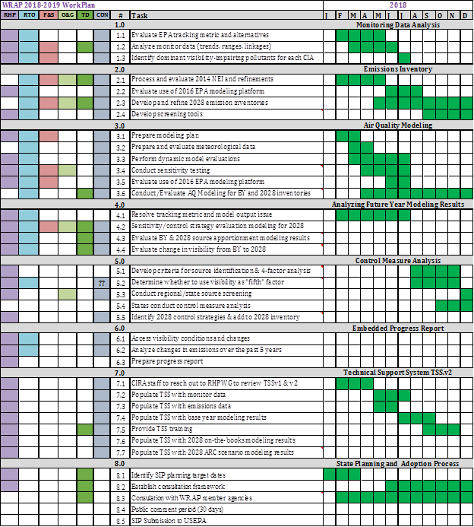

**WRAP Workplan Timeline to Support Regional Technical Analysis**

